1 задание:
-- MySQL Script generated by MySQL Workbench
-- Wed Feb 28 09:11:31 2024
-- Model: New Model Version: 1.0
-- MySQL Workbench Forward Engineering

SET @OLD_UNIQUE_CHECKS=@@UNIQUE_CHECKS, UNIQUE_CHECKS=0;
SET @OLD_FOREIGN_KEY_CHECKS=@@FOREIGN_KEY_CHECKS, FOREIGN_KEY_CHECKS=0;
SET @OLD_SQL_MODE=@@SQL_MODE, SQL_MODE='ONLY_FULL_GROUP_BY,STRICT_TRANS_TABLES,NO_ZERO_IN_DATE,NO_ZERO_DATE,ERROR_FOR_DIVISION_BY_ZERO,NO_ENGINE_SUBSTITUTION';

-- -----------------------------------------------------
-- Schema firstModel
-- -----------------------------------------------------

-- -----------------------------------------------------
-- Schema firstModel
-- -----------------------------------------------------
CREATE SCHEMA IF NOT EXISTS `firstModel` DEFAULT CHARACTER SET utf8 ;
USE `firstModel` ;

-- -----------------------------------------------------
-- Table `firstModel`.`user`
-- -----------------------------------------------------
CREATE TABLE IF NOT EXISTS `firstModel`.`user` (
`id` INT NOT NULL AUTO_INCREMENT,
`firstname` VARCHAR(45) NOT NULL,
`secondname` VARCHAR(45) NOT NULL,
PRIMARY KEY (`id`))
ENGINE = InnoDB;

-- -----------------------------------------------------
-- Table `firstModel`.`product`
-- -----------------------------------------------------
CREATE TABLE IF NOT EXISTS `firstModel`.`product` (
`idproduct` INT NOT NULL AUTO_INCREMENT,
`title` VARCHAR(100) NOT NULL,
`discription` TEXT NULL,
PRIMARY KEY (`idproduct`))
ENGINE = InnoDB;

-- -----------------------------------------------------
-- Table `firstModel`.`invoice`
-- -----------------------------------------------------
CREATE TABLE IF NOT EXISTS `firstModel`.`invoice` (
`idinvoice` INT NOT NULL AUTO_INCREMENT,
`userid` INT NOT NULL,
`productid` INT NOT NULL,
`cost` DECIMAL(10,2) NOT NULL,
PRIMARY KEY (`idinvoice`),
INDEX `user_idx` (`userid` ASC) VISIBLE,
INDEX `prod_idx` (`productid` ASC) VISIBLE,
CONSTRAINT `user`
FOREIGN KEY (`userid`)
REFERENCES `firstModel`.`user` (`id`)
ON DELETE CASCADE
ON UPDATE CASCADE,
CONSTRAINT `prod`
FOREIGN KEY (`productid`)
REFERENCES `firstModel`.`product` (`idproduct`)
ON DELETE CASCADE
ON UPDATE CASCADE)
ENGINE = InnoDB;

SET SQL_MODE=@OLD_SQL_MODE;
SET FOREIGN_KEY_CHECKS=@OLD_FOREIGN_KEY_CHECKS;
SET UNIQUE_CHECKS=@OLD_UNIQUE_CHECKS;

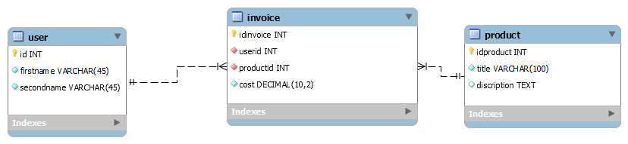

2) задание
-- MySQL Script generated by MySQL Workbench
-- Wed Feb 28 09:32:24 2024
-- Model: New Model Version: 1.0
-- MySQL Workbench Forward Engineering

SET @OLD_UNIQUE_CHECKS=@@UNIQUE_CHECKS, UNIQUE_CHECKS=0;
SET @OLD_FOREIGN_KEY_CHECKS=@@FOREIGN_KEY_CHECKS, FOREIGN_KEY_CHECKS=0;
SET @OLD_SQL_MODE=@@SQL_MODE, SQL_MODE='ONLY_FULL_GROUP_BY,STRICT_TRANS_TABLES,NO_ZERO_IN_DATE,NO_ZERO_DATE,ERROR_FOR_DIVISION_BY_ZERO,NO_ENGINE_SUBSTITUTION';

-- -----------------------------------------------------
-- Schema mydb
-- -----------------------------------------------------

-- -----------------------------------------------------
-- Schema mydb
-- -----------------------------------------------------
CREATE SCHEMA IF NOT EXISTS mydb DEFAULT CHARACTER SET utf8 ;
USE mydb ;

-- -----------------------------------------------------
-- Table mydb.users
-- -----------------------------------------------------
CREATE TABLE IF NOT EXISTS mydb.users (
id INT NOT NULL AUTO_INCREMENT,
fio VARCHAR(255) NOT NULL,
login VARCHAR(255) NULL,
password VARCHAR(255) NULL,
e_mail VARCHAR(255) CHARACTER SET 'ascii' NULL,
type VARCHAR(45) NULL,
PRIMARY KEY (id, fio),
UNIQUE INDEX id_UNIQUE (id ASC) VISIBLE,
UNIQUE INDEX login_UNIQUE (login ASC) VISIBLE)
ENGINE = InnoDB;

-- -----------------------------------------------------
-- Table mydb.settings
-- -----------------------------------------------------
CREATE TABLE IF NOT EXISTS mydb.settings (
id INT NOT NULL,
host VARCHAR(45) NULL,
db VARCHAR(45) NULL,
user VARCHAR(45) NULL,
password VARCHAR(45) NULL,
PRIMARY KEY (id))
ENGINE = InnoDB;

-- -----------------------------------------------------
-- Table mydb.shops
-- -----------------------------------------------------
CREATE TABLE IF NOT EXISTS mydb.shops (
id INT NOT NULL AUTO_INCREMENT,
name VARCHAR(255) NULL,
address VARCHAR(255) NULL,
tel VARCHAR(100) NULL,
site VARCHAR(100) NULL,
email VARCHAR(100) NULL,
PRIMARY KEY (id),
UNIQUE INDEX id_UNIQUE (id ASC) VISIBLE)
ENGINE = InnoDB;

-- -----------------------------------------------------
-- Table mydb.product_type
-- -----------------------------------------------------
CREATE TABLE IF NOT EXISTS mydb.product_type (
id INT NOT NULL AUTO_INCREMENT,
name VARCHAR(255) NULL,
PRIMARY KEY (id))
ENGINE = InnoDB;

-- -----------------------------------------------------
-- Table mydb.products
-- -----------------------------------------------------
CREATE TABLE IF NOT EXISTS mydb.products (
id INT NOT NULL AUTO_INCREMENT,
name VARCHAR(45) NOT NULL,
shop_id INT NULL,
type_id INT NULL,
brand VARCHAR(255) NULL,
model VARCHAR(255) NULL,
data TINYTEXT NULL,
img VARCHAR(255) NULL,
price VARCHAR(45) NULL,
warranty VARCHAR(45) NULL,
`` VARCHAR(45) NULL,
PRIMARY KEY (id),
UNIQUE INDEX id_UNIQUE (id ASC) VISIBLE,
INDEX product_to_type_idx (type_id ASC) VISIBLE,
CONSTRAINT shop_to_products
FOREIGN KEY ()
REFERENCES mydb.shops ()
ON DELETE NO ACTION
ON UPDATE NO ACTION,
CONSTRAINT product_to_type
FOREIGN KEY (type_id)
REFERENCES mydb.product_type (id)
ON DELETE NO ACTION
ON UPDATE NO ACTION)
ENGINE = InnoDB;

-- -----------------------------------------------------
-- Table mydb.deliveries
-- -----------------------------------------------------
CREATE TABLE IF NOT EXISTS mydb.deliveries (
order_id INT NOT NULL,
fio INT NULL,
address VARCHAR(255) NULL,
time VARCHAR(45) NULL,
date DATE NULL,
confirm TINYINT NULL,
deliveriescol VARCHAR(45) NULL,
PRIMARY KEY (order_id))
ENGINE = InnoDB;

-- -----------------------------------------------------
-- Table mydb.orders
-- -----------------------------------------------------
CREATE TABLE IF NOT EXISTS mydb.orders (
id INT NOT NULL,
shop_id INT NULL,
product_id INT NULL,
fio INT NULL,
date DATE NULL,
quantity TINYINT NULL,
tel VARCHAR(100) NULL,
confirm TINYINT NULL,
PRIMARY KEY (id))
ENGINE = InnoDB;
-- -----------------------------------------------------
-- Table mydb.user
-- -----------------------------------------------------
CREATE TABLE IF NOT EXISTS mydb.user (
username VARCHAR(16) NOT NULL,
email VARCHAR(255) NULL,
password VARCHAR(32) NOT NULL,
create_time TIMESTAMP NULL DEFAULT CURRENT_TIMESTAMP);

SET SQL_MODE=@OLD_SQL_MODE;
SET FOREIGN_KEY_CHECKS=@OLD_FOREIGN_KEY_CHECKS;
SET UNIQUE_CHECKS=@OLD_UNIQUE_CHECKS;

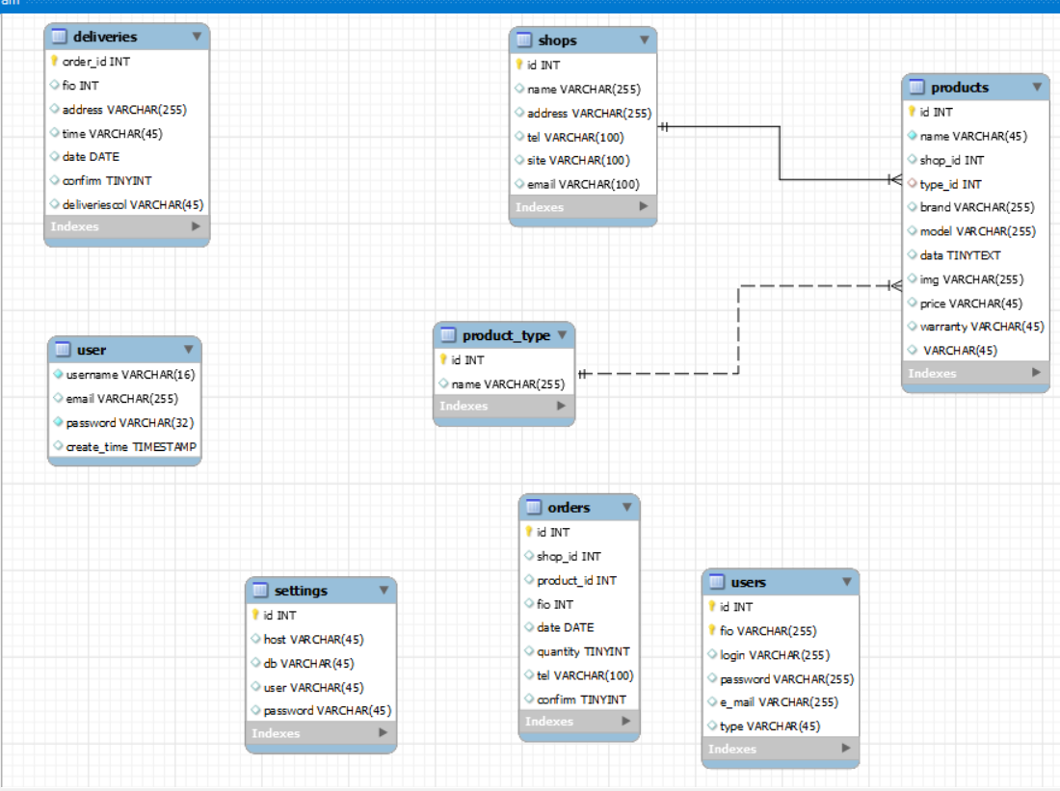

3 задание

4 задание

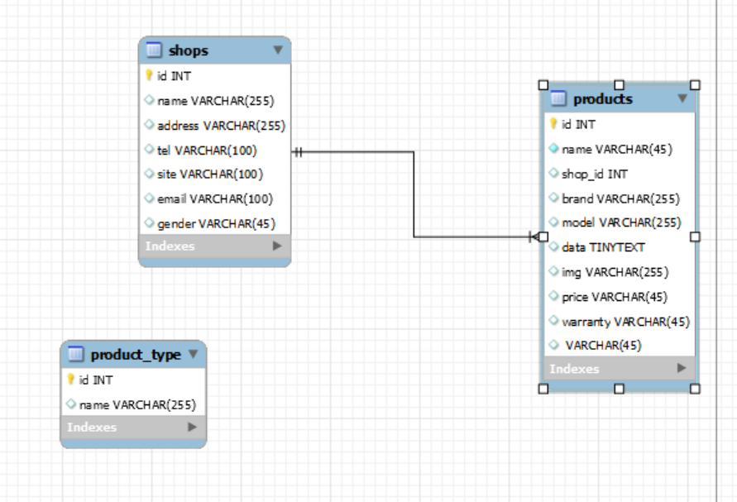
после удаления связанных полей связи пропадают

